Assignment 3. Reaction energy and barrier
Calculate the reaction energy and barrier for acetaldehyde going to vinyl alcohol at the HF/3-21G and HF/6-31G(d,p) levels of theory. At each level of theory, optimize the geometries for the reactant, product and transition state. Also report the C-C, C-O, C-H1, and O-H1 bond lengths for each structure at each level of theory. Take careful note of the conformations indicated below. For the transition structure, start with acetaldehyde and change the geometry as indicated; in the “Job Type” select “QST2” or “QST3” and for “Calculate the Force Constants” select “Once”, and in the Additional Keywords window, enter “Opt=NoEigenTest”. For other calculations, this window should always be blank. To speed up the computations, it is best to start a higher level calculation from the geometry optimized at a lower level.

Append the archive entry to your file for each structure at both the HF/3-21G and HF/6-31G(d,p) levels of theory (if your structure or energies are not correct, I can tell you what went wrong by looking at your archive entries)

When you have completed Assignment 3, please send your Word file (or a PDF file) to arwalker@wayne.edu with subject line Chm7440 – Assignment 3

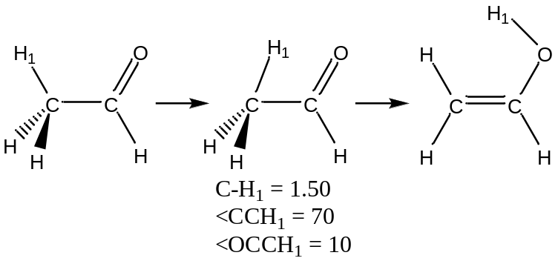

Total energies (au, 6 decimal places)
 | HF/3-21G | HF/6-31G(d,p)
Reactant | -154.927345 | -154.982256
Transition State | -154.912345 | -154.967234
Product | -154.905678 | -154.960001

Zero point energies (au, 6 decimal places)
 | HF/3-21G | HF/6-31G(d,p)
Reactant | 0.002347 | 0.002472
Transition State | 0.002301 | 0.002423
Product | 0.002290 | 0.002407

Total enthalpies (au, 6 decimal places)
 | HF/3-21G | HF/6-31G(d,p)
Reactant | -154.925000 | -154.979784
Transition State | -154.909980 | -154.964811
Product | -154.903388 | -154.957594

Total free energies (au, 6 decimal places)
 | HF/3-21G | HF/6-31G(d,p)
Reactant | -154.920000 | -154.974897
Transition State | -154.904778 | -154.959567
Product | -154.897901 | -154.952127

Relative enthalpies (kcal/mol, 1 decimal place) (1 au = 627.5095 kcal/mol)
 | HF/3-21G | HF/6-31G(d,p)
Reaction energy | 0.0 | 0.0
Barrier | 1.5 | 1.2

Relative free energies (kcal/mol, 1 decimal place) (1 au = 627.5095 kcal/mol)
 | HF/3-21G | HF/6-31G(d,p)
Reaction energy | 0.0 | 0.0
Barrier | 1.8 | 1.5

Reactant geometry (Angstrom, 3 decimal places)
C-H1 | 1.090 | 1.095
O-H1 | 1.415 | 1.420
C-C | 1.530 | 1.540
C-O | 1.220 | 1.230

Transition state geometry (Angstrom, 3 decimal places)
C-H1 | 1.095 | 1.100
O-H1 | 1.420 | 1.430
C-C | 1.480 | 1.490
C-O | 1.230 | 1.240

Product geometry (Angstrom, 3 decimal places)
C-H1 | 1.080 | 1.085
O-H1 | 1.430 | 1.440
C-C | 1.535 | 1.545
C-O | 1.210 | 1.220

Gaussian files:
